COE 292 – Final Project Report
Course: COE 292 – Introduction to Artificial Intelligence
Team ID: 01
Team Members: AlBaraa Barakat 202279220, Abdullah Alhuzaimi 202347290, Ghaith Altalahmeh 202448340
Dataset Selected: Dataset Selected: Maternal Health Risk Dataset – UCI ML Repository, predicting maternal risk levels during pregnancy

- Dataset Exploration and Preparation (10 points)
Before Cleanup:
• Number of samples: [ 1014]
• Number of features: [ 6]
• Number of classes: [ 3]
• Class distribution (samples per class): [ low risk: 406 samples (40.0%), mid risk : 336 samples (33.1%), high risk: 272 samples (26.8%)]
• Preprocessing and scaling steps applied: We used label encoding to encode the different classes using from low to high as 2 to 0, respectively. We also deleted the duplicates, which removed bias.
• 5-fold (stratified) cross-validation setup: (We used sklearn's StratifiedKFold to set up the the 5 fold cross validation splitting).
Data Visualization (Required)
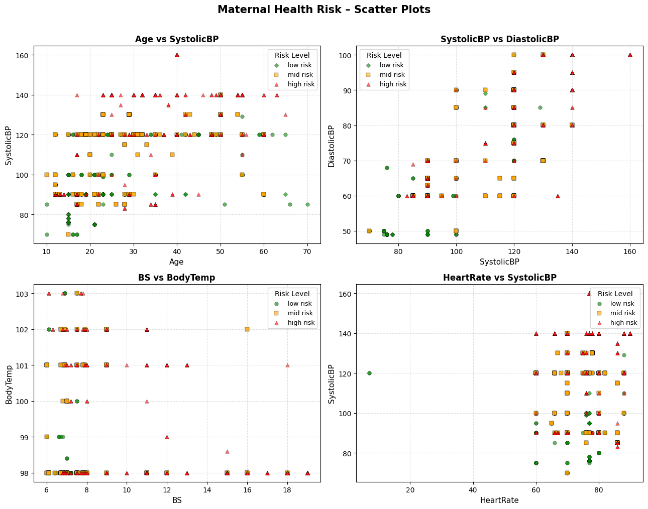

2. Classification Algorithm 1 – K-Nearest Neighbors (10 points)
•We used Euclidean distances as the distance unit for the KNNs. We also applied standard scaling to remove bias from columns that are made up of bigger numbers.
• We tested a range of K values from 1 to 21.
• According to the graph, a value of k=9 gave the best accuracy. Hence, were choosing k=9
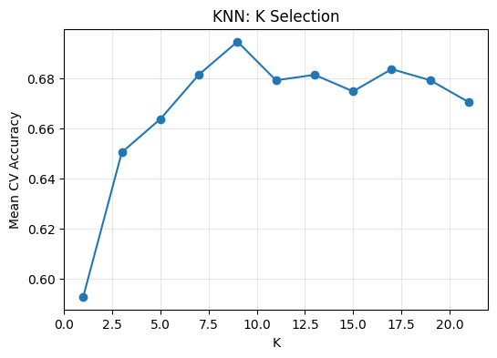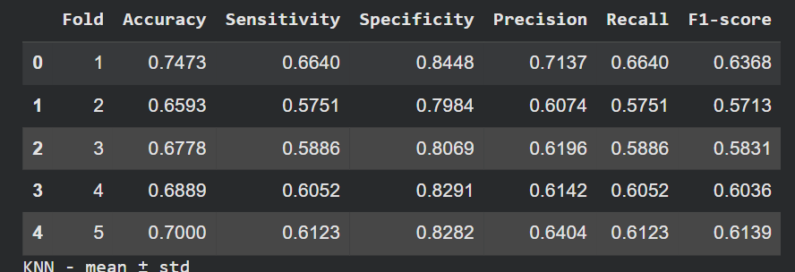

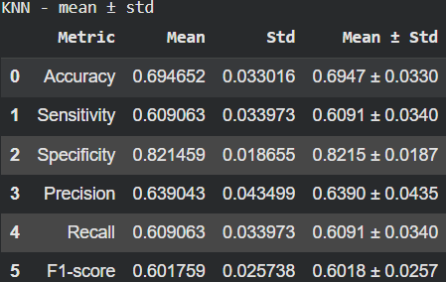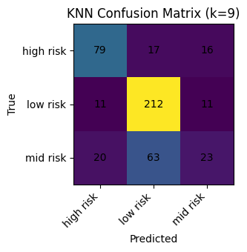

The figures indicate that the best K value was 9, and that accuracy after the 5 fold testing averaged at 70% with very small standard deviation. Due to the slight imbalance of the data, we can notice that the accuracy isn’t very consistent across the 5 folds.

3. Classification Algorithm 2 – Support Vector Machine (10 points)
• We used standard scali.
• Explanation of support vectors and decision boundary (observed pattern or plot).
• Kernel(s) tested and final kernel choice with justification.
• 5-fold cross-validation results (present as table and mean ± std).
• Performance metrics (Accuracy, Sensitivity, Specificity, Precision, Recall, F1-score, Confusion Matrix).
→ Expected: Clear presentation of kernel impact and results.

4. Classification Algorithm 3 – Deep Learning (MLP) (10 points)
• Network architecture: layers, neurons per layer, activation functions.
• Training parameters: learning rate, batch size, epochs (if applicable).
• 5-fold cross-validation results (present as table and mean ± std).
• Performance metrics (Accuracy, Sensitivity, Specificity, Precision, Recall, F1-score, Confusion Matrix).
→ Expected: Concise architecture diagram or table plus metrics summary.

5. Comparison and Conclusion (2 points)
• Compare KNN, SVM, and MLP results in a single table and/or bar plot of average performance metrics.
• Discuss strengths and weaknesses of each method (e.g., accuracy, complexity, training time).
• Conclude with key insights on classification importance and application relevance.
→ Expected: Balanced comparison with clear visual summary and interpretation.

6. Video Demonstration (5 minutes max – 8 points)
• Include a link to your demo video (YouTube unlisted or shared drive).
• The demo should show how to run the code and explain results clearly.
→ Expected: Concise, technically sound presentation covering workflow and key outputs.

Student Guidelines
• Font: Aptos (11 pt).
• Length: Maximum 5 pages (including plots and Instructor Checklist).
• Format: Concise bullet points or short paragraphs preferred.
• Figures: Ensure readability and proper labeling.
• Submission: Upload both report (PDF) and Jupyter Notebook to Blackboard / Gradescope.

Instructor Evaluation Checklist
Section | Max | Awarded | Criteria Met
Dataset Exploration and Preparation | 10 | [ ] | Dataset details, scaling, visualization, 5-fold setup
K-Nearest Neighbors (KNN) | 10 | [ ] | Scaling, K selection, cross-validation, metrics
Support Vector Machine (SVM) | 10 | [ ] | Scaling, kernel tests, support vectors, metrics
Deep Learning (MLP) | 10 | [ ] | Architecture, training params, cross-validation, metrics
Comparison and Conclusion | 2 | [ ] | Comparative table/plot + discussion and insights
Video Demonstration | 8 | [ ] | Clear and complete demo within 5 minutes
Total | 50

